

TOPIC : DMBS LAB WEEK2 ASSIGNMENT

NAME: D.JAGAN SAI ROHAN

REG NO: 19BBS0076

SLOT:L5+L6

Query: Create table Product(marker varchar(10),model int PRIMARY KEY,type varchar(20));

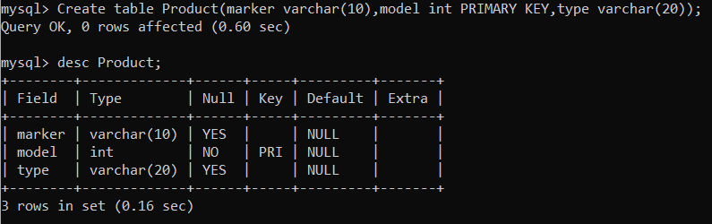

Query:Create table Laptop(code int PRIMARY KEY,model int, speed float,ram int,hd int,screen float, price int, foreign key(model) references Product(model))

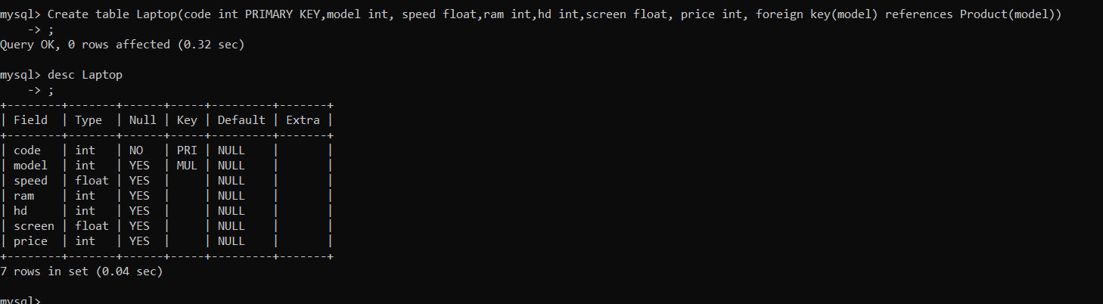

Query:Create table PC(code int PRIMARY KEY, model int,speed float,ram int,hd int,cd int, price int,foreign key(model) references Product(model));

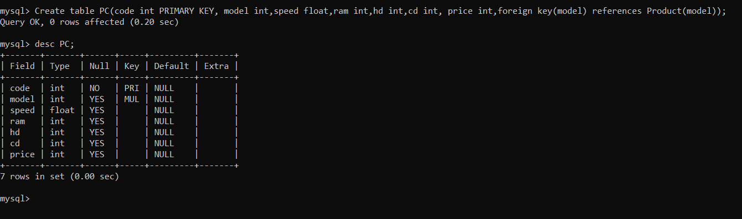

Query: Create table Printer(code int PRIMARY KEY, model int, ,color varchar(10),type varchar(20), price int, foreign key(model) references Product(model))

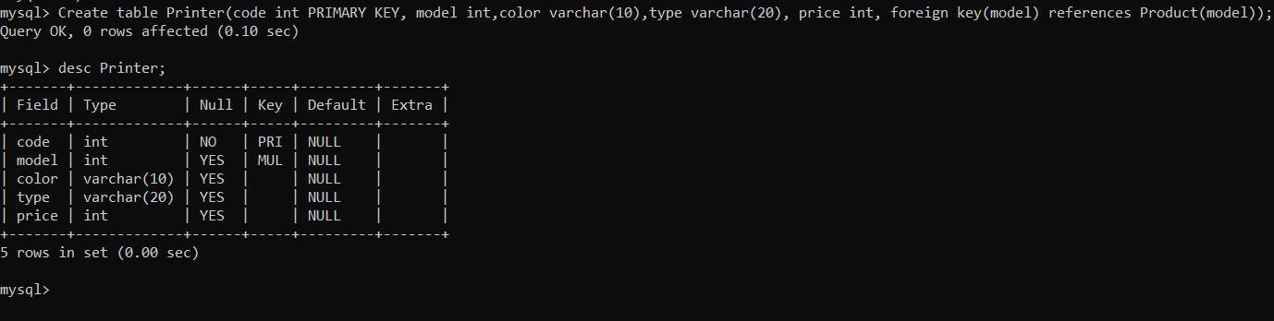

Query:INSERT INTO Product VALUES (‘L’, 5101, 'pc');

INSERT INTO Product VALUES ('L', 5102, 'pc');

INSERT INTO Product VALUES ('L', 5103, 'pc');

INSERT INTO Product VALUES ('M', 5104, 'pc');

INSERT INTO Product VALUES ('M', 5105, 'pc');

INSERT INTO Product VALUES ('M', 5106, 'pc');

INSERT INTO Product VALUES ('Q', 5107, 'pc');

INSERT INTO Product VALUES ('Q', 5108, 'pc');

INSERT INTO Product VALUES ('O',5 109, 'pc');

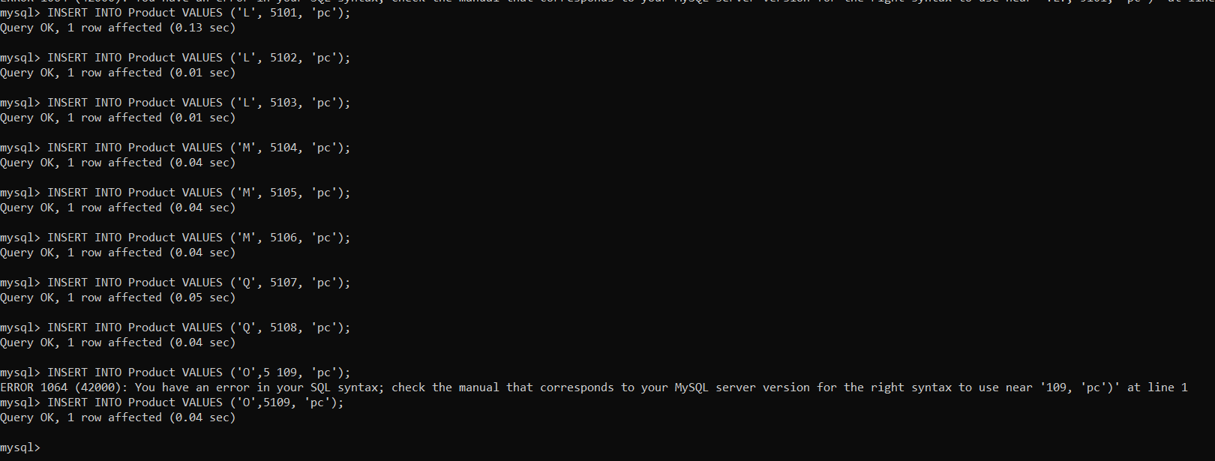

Query:INSERT INTO Product VALUES ('O', 6101, 'laptop');

INSERT INTO Product VALUES ('0', 6102, 'laptop');

INSERT INTO Product VALUES ('Q', 6103, 'laptop');

INSERT INTO Product VALUES ('Q', 6204, 'laptop');

INSERT INTO Product VALUES ('N', 6205, 'laptop');

INSERT INTO Product VALUES ('N', 6206, 'laptop');

INSERT INTO Product VALUES ('L', 6107, 'laptop');

INSERT INTO Product VALUES ('L', 6108, 'laptop');

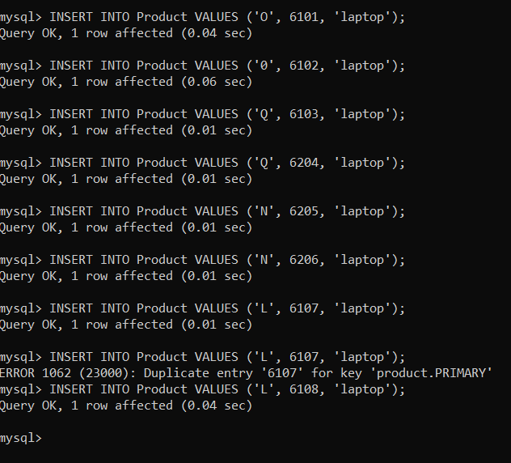

Query:INSERT INTO Product VALUES ('P', 7101, 'printer');

INSERT INTO Product VALUES ('P', 7102, 'printer');

INSERT INTO Product VALUES ('M', 7103, 'printer');

INSERT INTO Product VALUES ('M', 7104, 'printer');

INSERT INTO Product VALUES ('N', 7105, 'printer');

INSERT INTO Product VALUES ('N', 7106, 'printer');

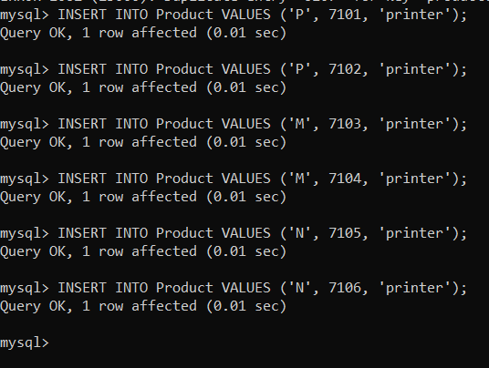

Query:Select \* from Product;

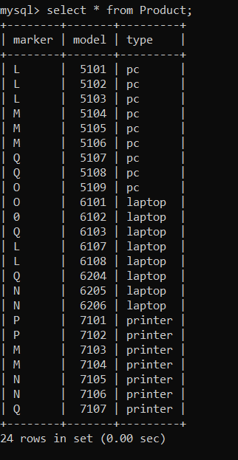

For Pc

Qeury:PC(code, model, speed, ram, hd, cd, price)-

INSERT INTO PC VALUES (1001, 5101,2.36, 512,60, 80, 650);

INSERT INTO PC VALUES (1002, 5102, 1.20, 2048, 120,80, 770);

INSERT INTO PC VALUES (1003, 5103,4.42, 2048, 240,250, 478);

INSERT INTO PC VALUES (1004, 5104, 3.20, 512, 80,320, 1049);

INSERT INTO PC VALUES (1005, 5105,2.20, 2048, 250,320, 490);

INSERT INTO PC VALUES (1006, 5106, 2.00, 512, 320,80, 550);

INSERT INTO PC VALUES (1007, 5107, 3.20, 512, 200,250, 630);

INSERT INTO PC VALUES (1008, 5108, 3.40, 1024,120, 320, 770);

INSERT INTO PC VALUES (1009, 5109,1.25, 512,100, 200, 2114);

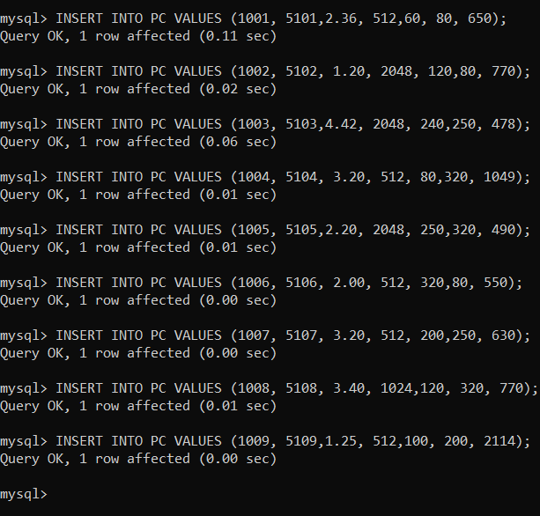

Query:Select \* from PC

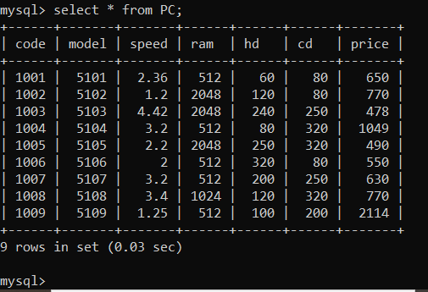

for Laptop

Query:Laptop(code, model, speed, ram, hd, screen, price)-

INSERT INTO Laptop VALUES (2001, 6101, 1.60, 512, 60,17.1, 949);

INSERT INTO Laptop VALUES (2002, 6102, 1.83, 2048, 240, 15.0, 3749);

INSERT INTO Laptop VALUES (2003, 6103,2.00, 1024, 80, 13.4, 1150);

INSERT INTO Laptop VALUES (2004, 6104, 1.92, 1024, 80, 17.3, 2250);

INSERT INTO Laptop VALUES (2005, 6105, 2.00, 2048, 240, 15.0, 1700);

INSERT INTO Laptop VALUES (2006, 6106, 2.16, 512, 120, 13.4, 1429);

INSERT INTO Laptop VALUES (2007, 6107, 1.78, 2048, 100, 17.1, 900);

INSERT INTO Laptop VALUES (2008, 6108,1.45, 2048, 120, 15.4, 949);

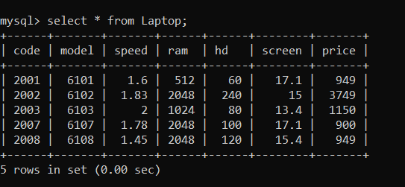

Query:INSERT INTO Printer VALUES (3001, 7101, ‘false’, ‘laser’, 139);

INSERT INTO Printer VALUES (3002, 7102,'false', ‘ink-jet’, 899);

INSERT INTO Printer VALUES (3003, 7103,'true', 'laser', 139);

INSERT INTO Printer VALUES (3004, 7104,'true', 'ink-jet', 99);

INSERT INTO Printer VALUES (3005, 7105,’true’, 'laser', 120);

INSERT INTO Printer VALUES (3006, 7106,’false’, 'ink-jet', 100);

INSERT INTO Printer VALUES (3007, 7107, 'true', 'laser', 99);

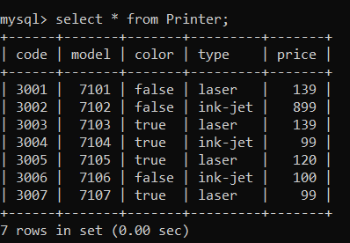

1. Find the model number, speed and hard drive capacity for all the PCs with prices below $500. Result set: model, speed, hd.

Query: select price,model,speed,hd from PC where price<500 group by model,speed,hd;

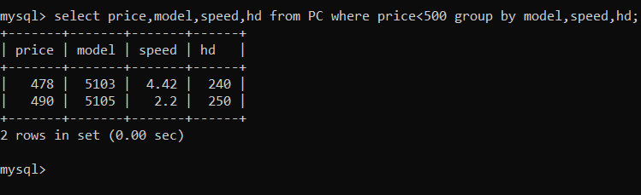

2. Find printer makers. Result set: maker

Query:Select distinct maker from Product where model in (select model from Printer);

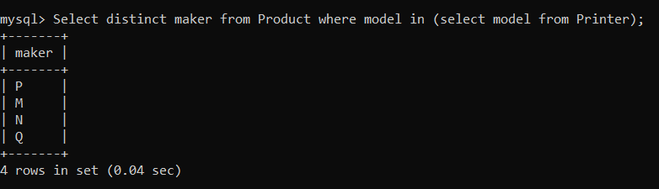

3.Find the model number, RAM and screen size of the laptops with prices over $1000

Query: Select model,ram,screen,price from Laptop where price > 1000;

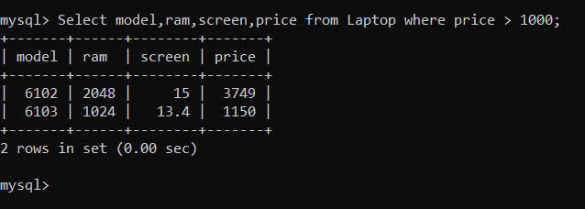

4.Find the model number, speed and hard drive capacity of the PCs having 12x CD ands prices less than $600 or having 24x CD and prices less than $600.

Query: Select model,speed,hd from PC where PC.cd IN (12,24) and price<600;

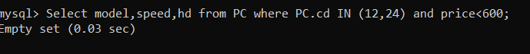

5. For each maker producing laptops with a hard drive capacity of 10 Gb or higher, find the speed of such laptops. Result set: maker, speed.

Query:Select distinct maker,speed from Product,Laptop where Laptop.hd>=10 and type in (select type from Product where type=’laptop’);

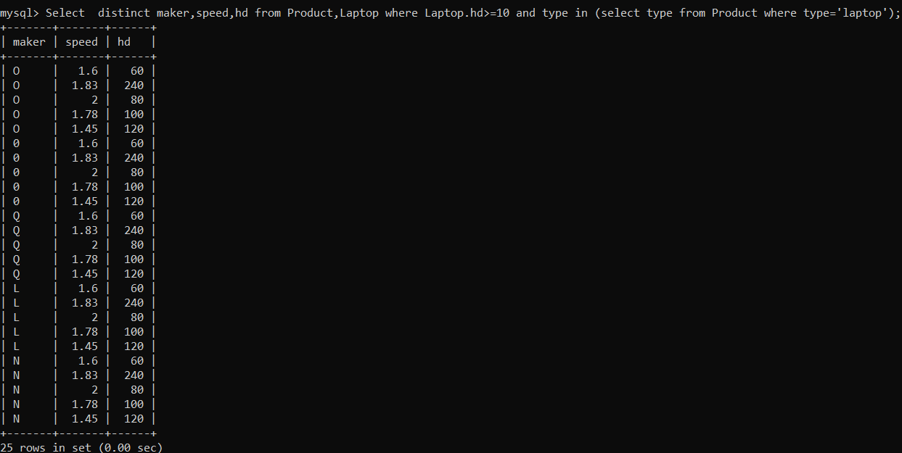

6. Find out the models and prices for all the products (of any type) produced by maker B.

Query: Select model,price from PC where model in (Select model from Product where maker =’M’ and type=’pc’) union select model,price from Laptop where model in (select model from Product where maker=’M’ and type=’laptop’) union select model,price from printer where model in (select model from Product where maker=’M’ and type=’printer’);

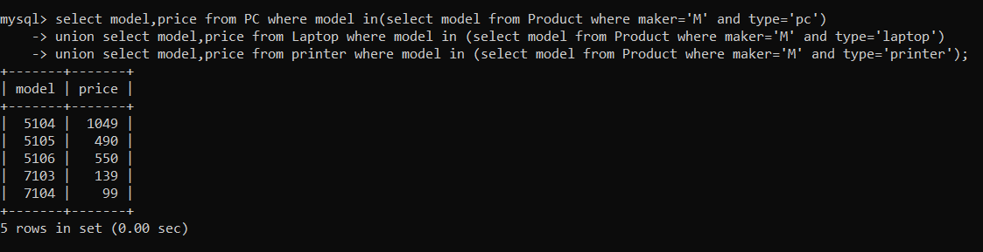

7. Find out the makers that sale PCs but not laptops.

Query: select distinct maker from Product where type ='pc' and not (type='laptop');

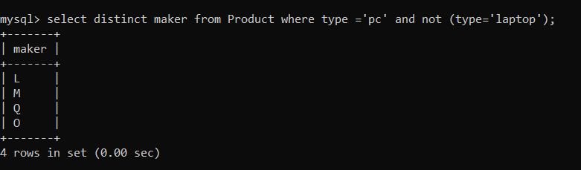

8. . Find the printers having the highest price. Result set: model, price.

Query: Select model,max(price) from Printer;

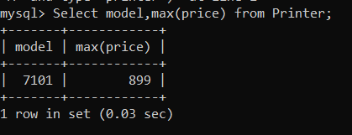

9. Find all the makers who have all their models of PC type in the PC table

Query: Select distinct maker from Product where model in (select model from Product where type=’pc’);

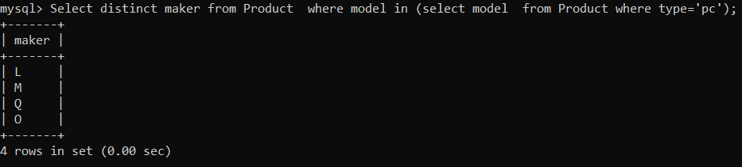

10. . Find out the average speed of the PCs produced by maker A.

Query:Select model,avg(speed) from PC where model in (select model from Product where maker=’L’ and type=’pc’);

